**OUR PROBLEM STATEMENT:**

PROBLEM STATEMENT NO-3 SMART CITIES

We are catering for the problem of public safety which includes developing solutions to enhance public safety and emergency response mechanisms.

**We are majorly focusing on the problem of rapid disaster response and recovery.**

**OUR SOLUTION:**

We are making a web/app-based platform which connects disaster management agencies to the user.

* Rescue Teams login with unique IDs which would be government-verified.
* Rescue Teams enter into the database which will be displayed to the user.
* The user in need will directly go to the alert button to send an alert.
* The user’s location would be sent to the nearest rescue team.
* A map with all the nearest rescue centres and shelters will be displayed to the user.
* A Rescue Team can send an alert to another rescue team for reinforcements.
* 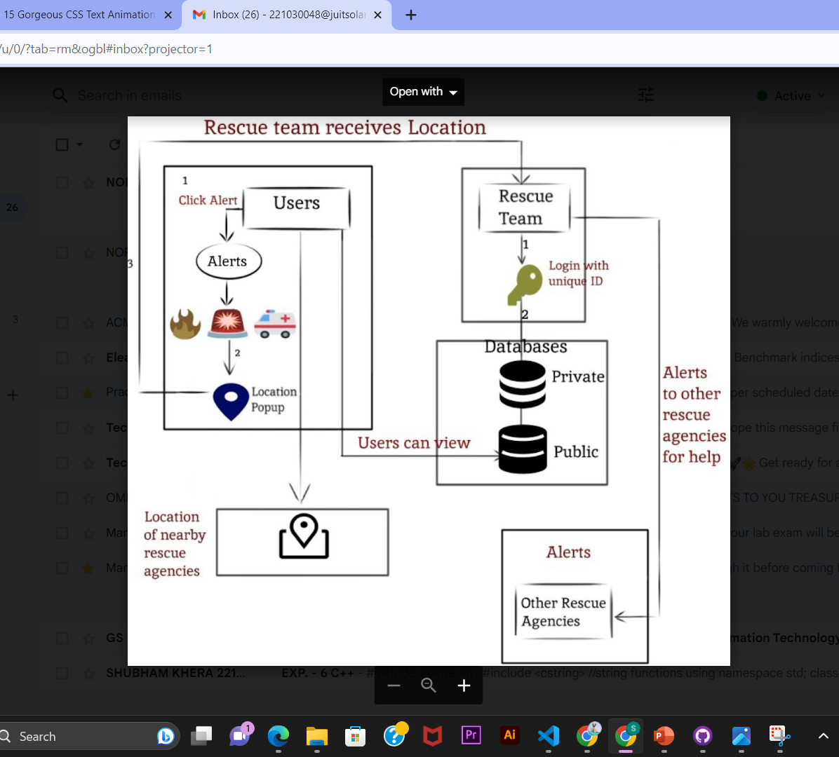

**The website works the following way:**

* **Government-Backed Credentials:** Rescue teams gain access through exclusive, government-verified IDs, ensuring the utmost trust and security.
* **Comprehensive Database:** Teams input crucial data into a centralized database.
* **Instant SOS:** In moments of crisis, users can swiftly access the alert button. Their location would be directly sent to a rescue agency.
* **Interactive Map:** A dynamic map interface, revealing the location of nearby rescue agencies also rescue centres and shelters, providing users with a clear path to safety.
* **Unified Response:** With the ability to send alerts to fellow rescue teams, the system empowers teams to swiftly summon reinforcements, enhancing their capacity to address escalating emergencies effectively.

**Use Cases:**

* **Rapid Response Contacts:** Equipping users with readily

accessible contact information for local emergency services, government agencies, and non-governmental organizations creates a vital lifeline, connecting individuals swiftly with the right authorities during times of need.

* **Guidance Through Crisis**: Providing Intricate Evacuation routes and detailed maps serve as a guiding light assisting people in charting the safest paths to escape affected areas.
* **One-Touch Emergency Access:** The inclusion of an

immediate-access emergency button empowers users with a single, quick touch point for essential information and resources. This streamlined approach ensures that crucial assistance is just a click away, eliminating the need for complex navigation through multiple web pages or menus.

* **Interface between Users and Rescue Teams:** The website acts as an interface between the users and the rescue teams. The database of the rescue teams can be easily accessed by the user.
* **Alert System:** Users can directly go to the alert page and send alerts as per the aid they want to receive. This alert system provides instant notifications to the nearest rescue teams when the user presses the alert buttons.
* **Shared Resources:** The rescue teams can coordinate among themselves and share resources in case of emergencies.

**FUTURE IMPLICATIONS:**

* IOT-based single-click button system.
* Damage assessment and reporting.
* Fundraising for affected communities.

**TEAM MEMBERS:**

Sanya Jain -TX240686

Norin Sharma -TX240673